Klamath Housing Authority

Individual Development Account (IDA) Initiative

The Oregon IDA Initiative invests in the personal and financial growth of individuals to build strong communities in Oregon. Individual Development Accounts, or IDAs, are matched savings accounts that build the financial management skills of qualifying Oregonians with lower incomes while they save towards a defined goal. IDA’s open up pathways of opportunity and create models of economic success in Oregon communities. The Oregon IDA Initiative is managed by Neighborhood Partnerships, a partner of the State of Oregon. To learn more, visit https://oregonidainitiative.org/

Participants enroll, set a goal and begin saving. For every $1 you save, you receive a match of an additional $5. You can save up to $1,800.00 of your own participant funds and be matched up to $9,000.00! Your match amount is determined at the time of application approval. The IDA participant and IDA Specialist will develop a savings plan agreement.

You may qualify if you can say “yes” to each of the following:
Income Limits
(Change annually)
HH Size | Annual Income
1 | $50850
2 | $58150
3 | $65400
4 | $72650
5 | $78500
6 | $84300
7 | $90100
8 | $95950

For education IDA’s you must be at least 12 years old. For home purchase, vehicle, and assisted technology, you must be at least 18 years old.
- My income is within the Income Limits, please refer to chart
- I am an Oregon resident
- You can commit to setting aside money on a regular basis (for a minimum of 6 months)
Klamath Housing Authority will require:

- Make IDA application with Klamath Housing Authority
- Provide proof of Oregon residency and income
- Make a savings and specific goal plan: Homeownership, Education, Assisted technology (Dental and Auto)
- Open an IDA Bank Account where you will make a minimum of $25 monthly deposits (can be more) for the goal period.
- Attend required classes that help you to build the financial skills, strength, and stability to reach your IDA goal
- Be willing to attend all education classes required
- Save a minimum of $25 monthly towards my asset goal
- Commit to saving for at least 6 months

For more eligibility information please visit:
https://oregonidainitiative.org/find-ida-provider/do-i-qualify-2/

IDA’s are about more than receiving match money.
IDA’s are about supporting you and your family in reaching your financial goals. This includes your savings, match money, and financial education, focused on supporting you in attaining your financial goals and building and managing assets.

For every one dollar you save, IDA initiative matches five dollars!
Maximum term = 36 months. Maximum participant savings funds $1,800.00
~YOU CHOOSE ~
Savings Examples:
YOUR TOTAL  Participant Funds | TERM | MONTHLY DEPOSIT | IDA MATCH | TOTAL FUNDS  Participant funds + Match funds
$600.00 | 6 MONTHS | $100.00 | $3000.00 | $3600.00
$600.00 | 12 MONTHS | $50.00 | $3000.00 | $3600.00
$600.00 | 24 MONTHS | $25.00 | $3000.00 | $3600.00
$1200.00 | 6 MONTHS | $200.00 | $6000.00 | $7200.00
$1200.00 | 12 MONTHS | $100.00 | $6000.00 | $7200.00
$1200.00 | 24 MONTHS | $50.00 | $6000.00 | $7200.00
$1800.00 | 12 MONTHS | $150.00 | $9000.00 | $10800.00
$1800.00 | 24 MONTHS | $75.00 | $9000.00 | $10800.00
$1800.00 | 36 MONTHS | $50.00 | $9000.00 | $10800.00

Berva: The IDA program has been an empowering experience for me. My goal is to receive certification as a drug and alcohol counselor. I used to commute via Basin Transit bus line to attend Klamath Community College every day. I enrolled in the IDA program, saved for one year and just purchased my car! None of this would have been possible without the amazing IDA program! Words cannot begin to describe the absolute elation and gratitude I feel each day I drive to KCC in MY CAR! I have learned the value of the dollar and the importance and ‘habit’ of saving!”

Anne: “The Dental goal through the IDA program has changed my life in a way I can’t really explain! I desperately needed a lot of dental work. NO way would I have ever been able to save for this on my own. The IDA process was easy for me, and it’s now the best feeling in the world to smile and feel comfortable!”

Teresa: “As a single mom, I was struggling to continuously keep up on the necessary repairs of my old vehicle. I was introduced to the IDA program and discovered I could actually afford to save a specific amount each month to achieve my goal of owning a new vehicle. I learned new budgeting tools and had guidance with major credit repair. I paid off all credit card debt, raised my credit score significantly, and created new habits for saving! This program taught me the value of financial stability!”

~KLAMATH COUNTY IDA INITIATIVE PARTICIPANT TESTIMONIALS~

Julie: “When I learned about the IDA program, I was intimidated and thought I could not possibly qualify or save. Once I began saving, all fears were put to rest! I awakened my mindset to a new narrative ~
‘I CAN instead of I CAN’T’! The useful information I learned in the financial fitness class exceeded my expectations and was better than any other class I have ever taken!”

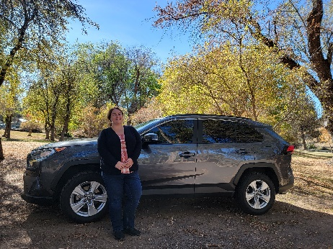

Contact Info: Michelle J. Scott (541) 884-0649 Ext. 120 e-mail: michelle@klamathhousing.org

